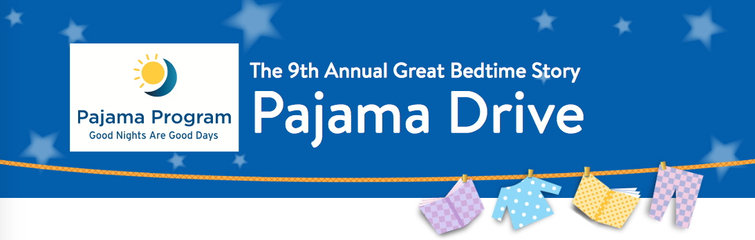
Dear CIS Families,
Our K-2 classrooms are eager to take action and participate in the annual Scholastic Book Clubs Great Bedtime Story Pajama Drive, but we need your help! The Pajama Program is a national nonprofit organization that provides new pajamas and storybooks to children living in shelters, group homes, and foster care, and those who attend Title I schools, Head Start programs, and other organizations that support at-risk youth. Scholastic Book Clubs will match the number of pajamas we collect with new storybooks! Our school wants to be part of this drive so that we can help make a better bedtime for children in need.
If you and your child are able to participate, please help us transform bedtime for a child by bringing a new pair of pajamas to school by Monday December 11, 2017. Our goal is to collect at least 10 pairs of pajamas per classroom. Those classrooms that reach the goal will be able to participate in a Pajama Party on Thursday, December 21, 2017 to celebrate our commitment! (Details to come!)
Here are some simple guidelines for the pajamas:
*Pajamas must be brand-new. Pajamas in all sizes are needed—from newborn to adult.
*Pajamas must be in complete sets or nightgowns.
*Pajamas in children’s sizes must be manufactured as pajamas—this ensures that they are flame- retardant and safe.
Thank you for helping us share the gift of a good night’s sleep and a sweet bedtime story. After all, good nights are good days!
Sincerely,
K-2 Teachers

